Name:_________________________________________ Date: ____________________

AS and A-level Physics Core Practical:
Investigation of the electromotive force, EMF (ɛ) and internal resistance (r) of electric cells and batteries by measuring the variation of the terminal pd of the cell with current in it.

Common Practical Assessment Criteria (CPAC) assessed: 1a, 2a-d, 3a, 4a, b

In this experiment you will measure the potential difference (V) across the terminals of a “button cell” for different currents (I) through it. The measurements will enable you to determine its EMF (ɛ) and internal resistance (r).

You are given a procedure to follow.

You need to use your skill to collect good quality data.

You need to choose correct ranges and connections on two digital multimeters

You need to draw a good graph, and use it to calculate ɛ and r

You will work in pairs to collect but you must analyse data individually

CPAC |  | met?
1
2 | a
 | b
 | c
 | d
3 | a
 | b
 | c
4 | a
 | b
5 | a
 | b

Learning objectives:
After completing the practical you should be able to:
- experimentally determine the internal resistance and electromotive force (EMF) of a cell or battery
- interpret a straight line graph, matching the gradient and intercepts to variables under investigation.
Background:
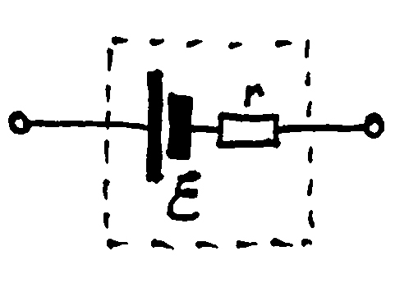
All electrical power sources produce a voltage, called the EMF (symbol ε), but the material the power source is constructed from also gives it a resistance, called the internal resistance (symbol r). This resistance opposes current flowing through the power source and causes energy dissipation inside it when in use. This energy loss reduces the terminal potential difference (pd) of the power source.

A real power source can be modelled as a pure source of voltage ε in series with a resistance r that is inseparable.

The pd across the battery terminals, V, is related to the current, I, by V = ε – Ir, where ε is the battery EMF.

In the case of a “button cell”, energy is transferred from the chemical store to the electrical store inside the battery. Some of this energy is dissipated to the thermal store inside the battery due to internal resistance, r.

Safety:

It is difficult to measure the value of r for a power source because you need to draw a high current from the power source, which is damaging for many types of power source as it quickly heats it up. It is important that you set the circuit up and only connect the battery momentarily to take a reading.

Equipment:

- Button cell marked (‘nominal’) 1.5v
- Variable resistor 0-16 Ohms approximately
- 2 x digital multimeters, use one as a voltmeter, one as an ammeter. It is essential that you set an appropriate range and connect the meters correctly.
- Connecting leads with 4mm plugs
- Camera (use your mobile phone camera or ask for one to be provided)

Diagram
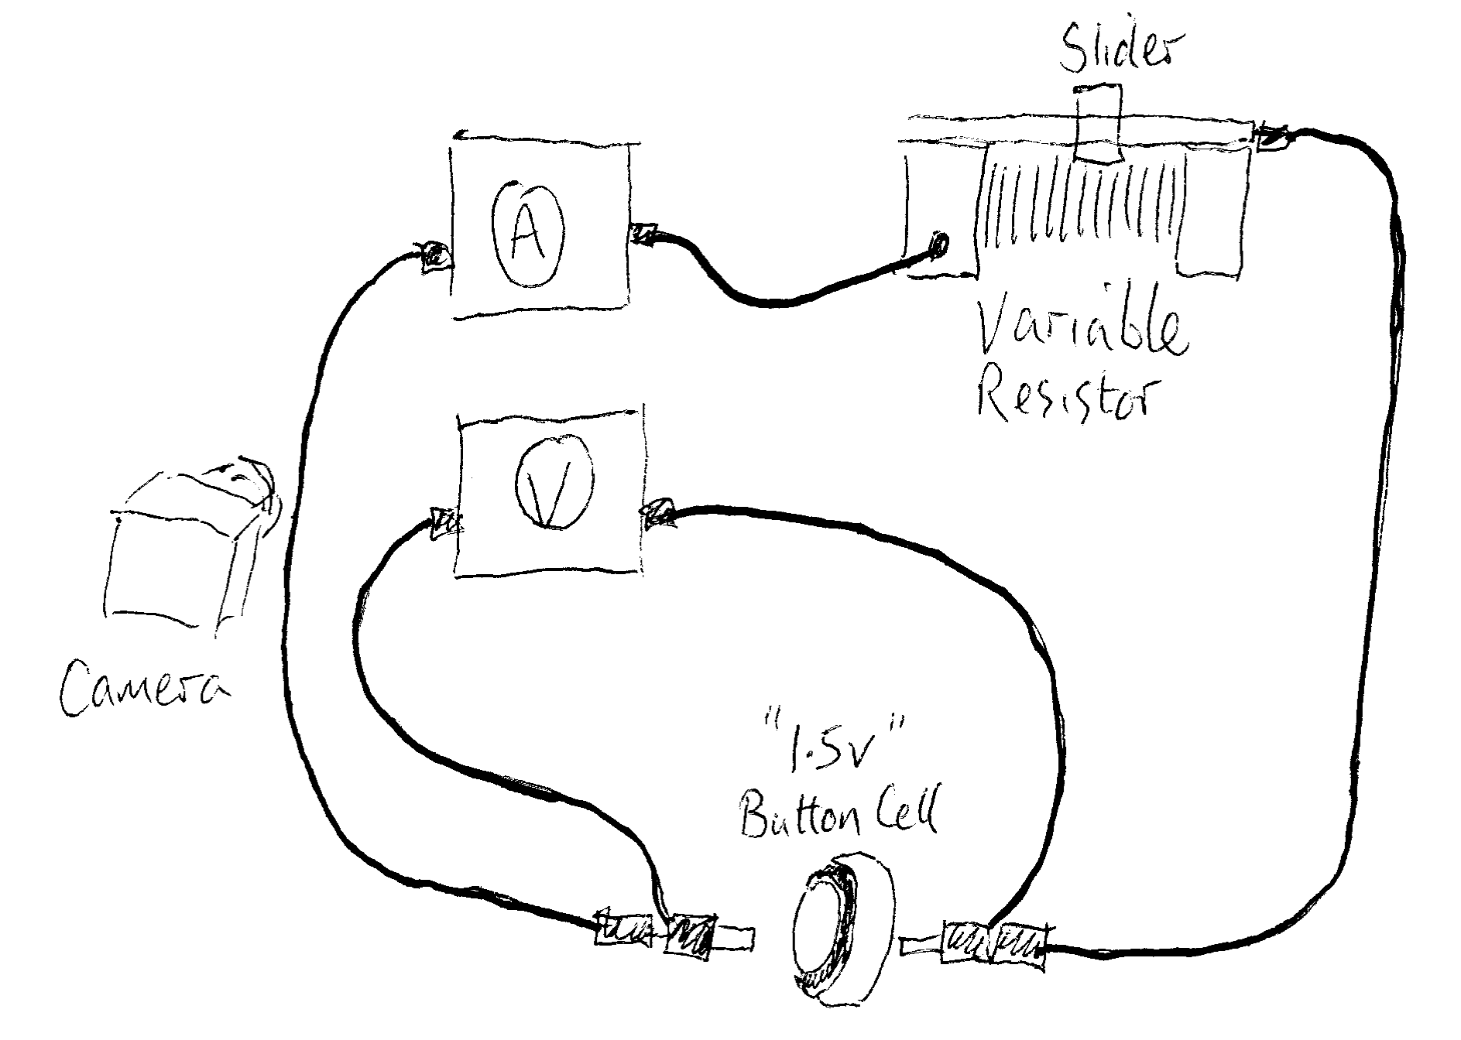
Procedure (read the instructions below carefully and construct a results table before you begin collecting data):

1. You will use one multimeter as an ammeter. The current might go as high as 0.5A in this experiment. Set this multimeter to an appropriate range and ensure that the connecting leads are inserted into the correct sockets for that range.

2. Set the other multimeter to an appropriate range for measuring the voltage across the cell (max 1.5 V) and ensure that the connecting leads are inserted into the correct sockets for that range.

3. Set up the circuit as shown in the diagram. Place the button cell on a lump of blu-tac to keep it upright. Place the multimeters next to each other. The free ends of the connecting wires can be used as a switch, completing the circuit so that current flows when they are touched to the opposite faces of the cell. To collect data for this experiment, you will momentarily connect the battery using the connecting wires. It is important that you do this for as little time as possible, and do not make permanent connections to the battery otherwise the battery will be damaged and you will not obtain good data.

4. Set the variable resistor slider to its maximum resistance. (You do not need to record the value of the resistor at any stage in the experiment).

6. When you are ready, hold the battery, and press the plugs to either side of it to make a connection. Wait a second or two for the voltage reading to settle.

7. Take a photograph of the multimeters, then disconnect the circuit. Use your photo to fill in an appropriate results table.

8. Re-connect the battery and wait for the voltmeter reading to become the same as it previously was (or as close to this as possible). Take another photo.

9. Repeat for another reading so you have three readings of voltage and current.

10. Do the above procedure several times, reducing the resistance of the variable resistor each time. Do not move the slider in equal steps. Instead set the slider about half way, then approximately 1/4, 1/8, etc. Until you have at least 6 readings. The last reading will be with the slider fully slid over to give minimum resistance.

Results Table:

This experiment involves you recording the terminal voltage (V) and the current (I) through a button cell. In the space below, draw a table that allows you to display repeated readings and includes appropriate headings and units:

Graph:

Construct a graph of Terminal p.d. / V (vertical axis) against Current /A (horizontal axis)

The graph should fill most of a sheet of A4 graph paper – though you must ensure that the y-intercept is visible. Add a straight line of best fit.

The intercept of the vertical axis is the value of the cell’s EMF (ɛ)
The gradient of the line of best fit is the negative of the internal resistance (r) of the battery. Remember that when finding the gradient of a straight line from a graph, you ought to use a triangle that spans all the points.

Questions:

Draw a circuit diagram of the circuit you used for this experiment:

Looking at your graph, explain why the procedure for the experiment does not use an even step size for reducing the resistance of the variable resistor: - not sure what answer is expected here?

________________________________________________________________________

________________________________________________________________________

________________________________________________________________________

From your graph, what is the EMF of the cell you used for your experiment?

________________________________________________________________________

From your graph, what is the internal resistance of the cell you used for your experiment?

________________________________________________________________________

