Investigating Capacitor Discharge Using a Data Logger

Equipment

DC supply eg 5V stabilised supply or 1.5 V alkaline cell
Capacitor 4700 µF nominal
Fixed resistor 330 Ω ± 1%
Double throw switch
Data logger with voltmeter

Theory

When a capacitor of capacitance C is discharged through a fixed resistance R, the pd across the capacitor V decreases exponentially with time t:

$$V=V_{0}e^{\frac{-t}{RC}}$$

where V₀ is the pd across the capacitor at time t = 0

Taking natural logs:
$$ln⁡(V)=ln{(V}_{0})-\frac{t}{RC}$$

By measuring the pd across the capacitor at different times as it is discharged, a graph of lnV against t can be drawn. This will be a straight line with gradient $\left(-\frac{1}{RC}\right)$ and intercept ln(V₀)

Procedure

Set up the circuit shown in the diagram:

Ensure that the indicated negative terminal of the capacitor is connected to the negative terminal of the cell or supply.

Set up the data logging software so that it records data every 50 ms for 10 s
Fully charge the capacitor and when the data logger is recording, discharge the capacitor by moving the double throw switch.

The data logging software may allow you to do the following directly but if not, export the data to an Excel spreadsheet.

The columns required are time in seconds and pd in Volts. If the logging started before the capacitor started to discharge, select all of the pd readings from before the pd started to drop.
While they are all selected, right click and select ‘clear contents’.
Then select all of the remaining pd readings and drag them upwards so that the first one is at time 0. (See screen shot below)

In the blank column to the right of the V values, click on the first cell and enter =ln( then click the pd cell to the left and then close the bracket. Press ‘enter’ or ‘return’. This should give the ln(V) value for t = 0. Hover over the bottom left of the cell until the small bold + sign appears and drag it all the way down so that the values of V have their natural log value calculated.

To insert a graph, first select the time values required. Then hold down ‘Ctrl’ and select the ln(V) values. From the ‘Insert’ menu select ‘charts’ and ‘scatter’:

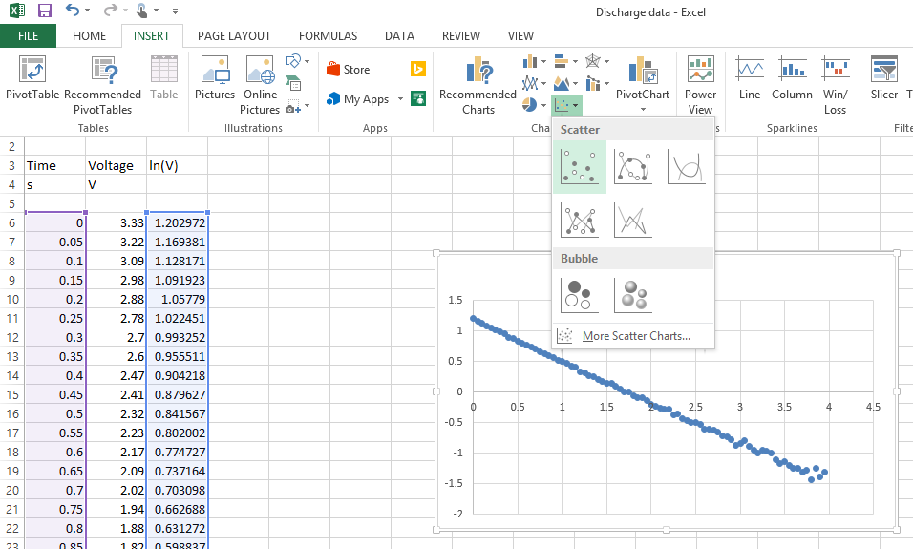

Right click on the graph points and select ‘Format trend line’. Select ‘Linear’ and ‘Display equation on chart’.

Axis titles and other formatting can be added here or the graph can be printed, attached to the lab book and written on. The important thing is that the equation of the line which gives the gradient and the intercept is displayed.

Use the data to make a comment on the accuracy of the stated values of the capacitor and the resistor.

