**allergies**

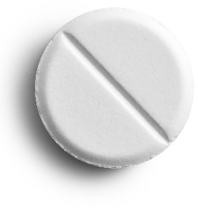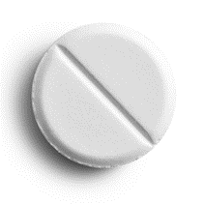

8 tablets

Take 2 tablets every 6 hours.

cost: £10

**cough**

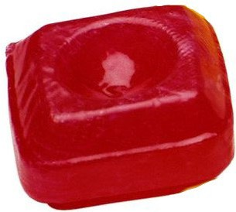

12 lozenges

Take when needed. Do not take more than 6 in one day.

cost: £10

**cough**

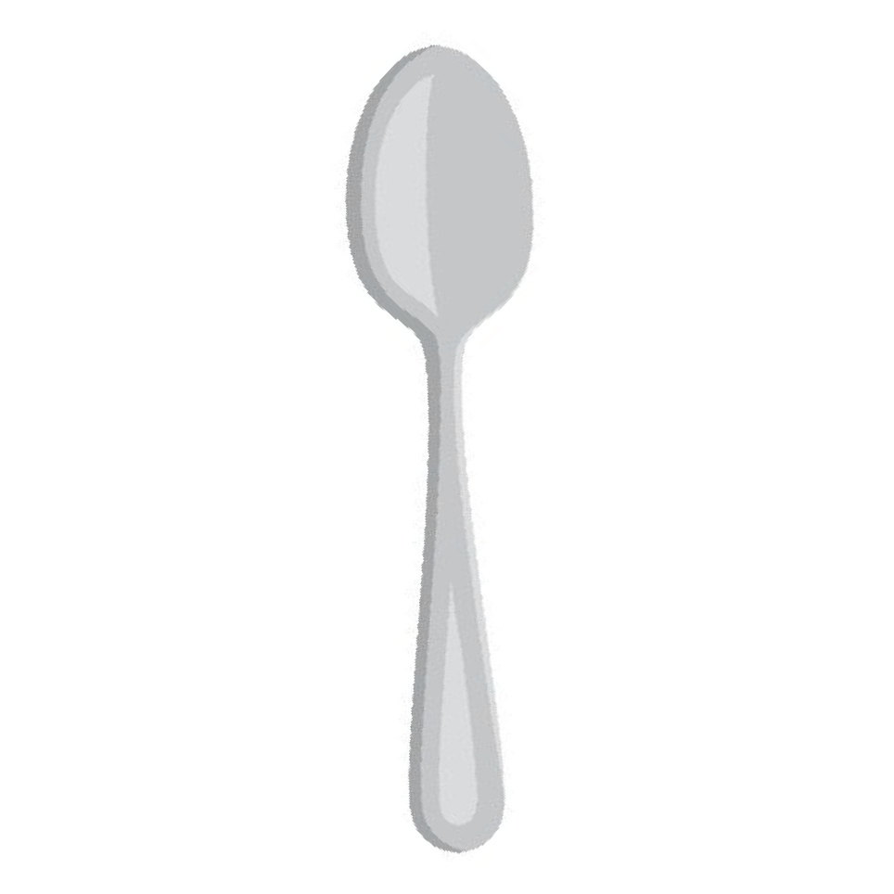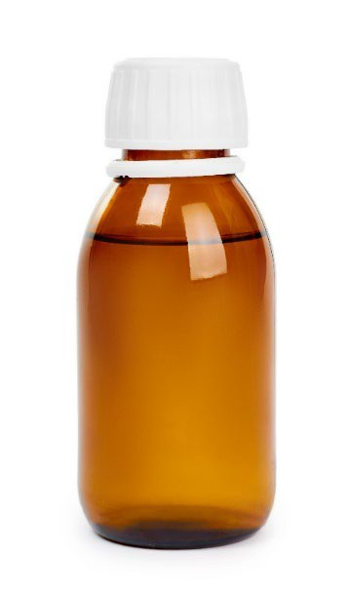

300ml bottle of

cough mixture

Take 1 spoonful every 6 hours.

cost: £10

**ear ache**

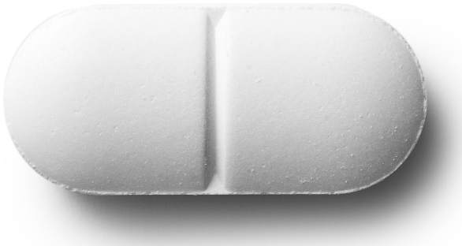

10 tablets

Take 1 tablet every 3 hours.

cost: £10

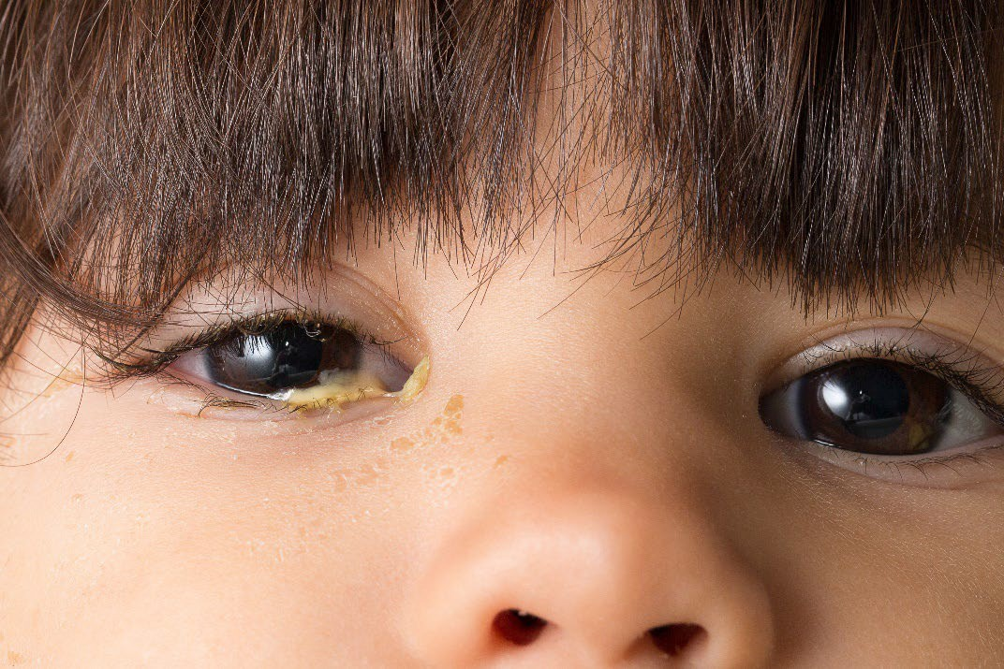

**eye infection**

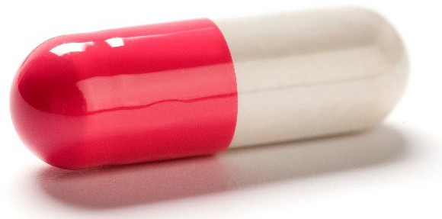

12 capsules

Take 1 capsule every 2 hours.

cost: £10

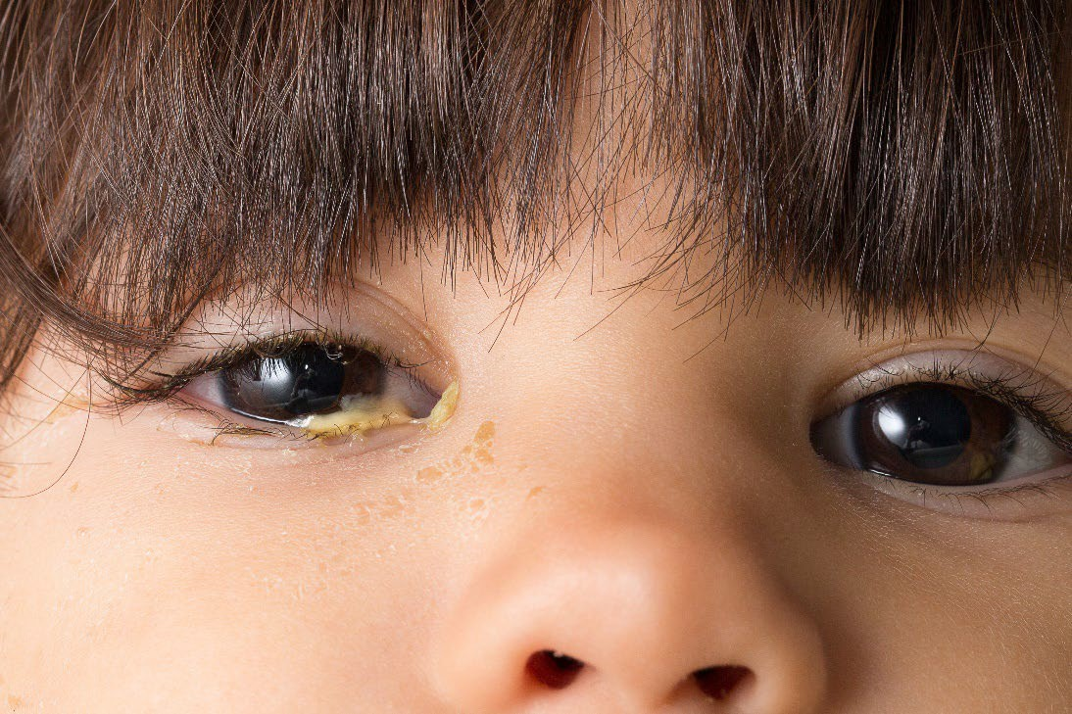

**eye infection**

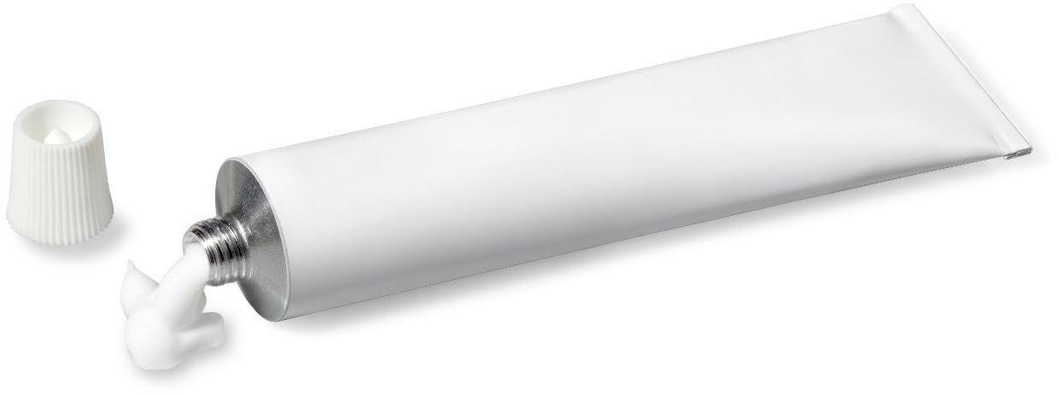

1 tube of ointment

Apply to eye every 3 hours.

cost: £10

**head ache**

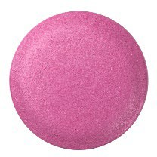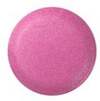

10 tablets

Take 2 tablets every 6 hours.

cost: £10

**head lice**

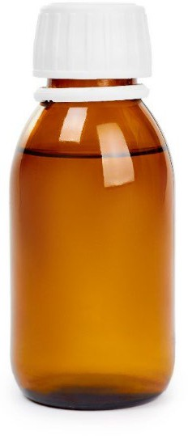

150 ml head

lice solution

Put all over hair.

Wash off after 1 hour.

cost: £10

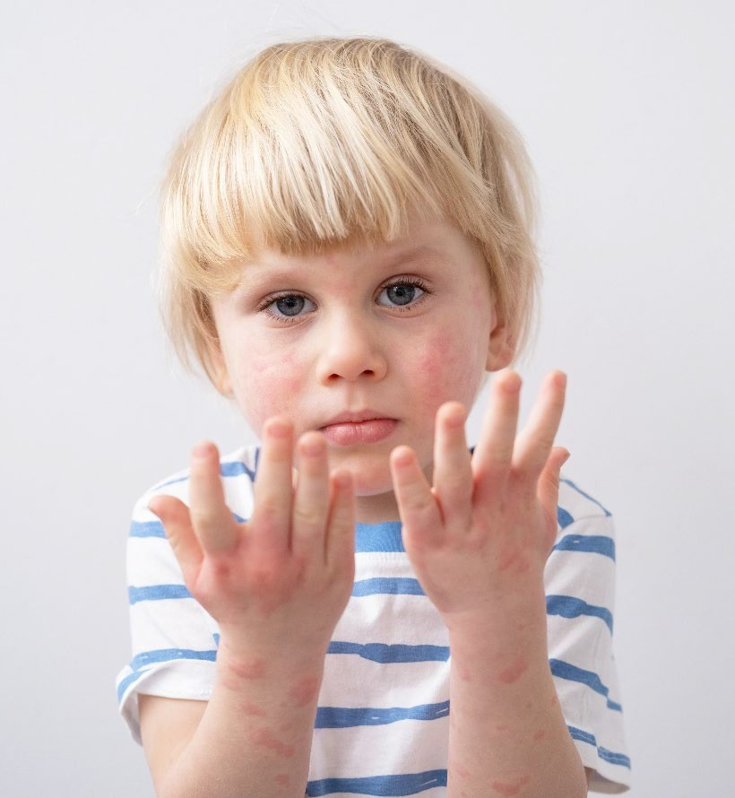

**rash**



1 tube of cream

Apply to skin every 4 hours.

cost: £10



**rash**

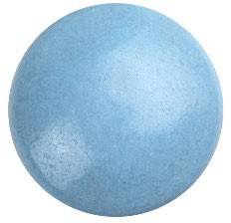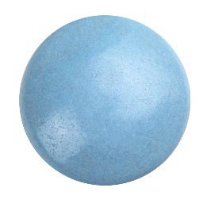

12 tablets

Take 2 tablets every 3 hours.

cost: £10



**sore legs**

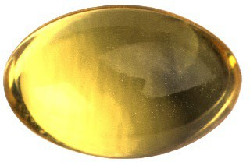

14 capsules

Take 2 per day for a week.

cost: £10

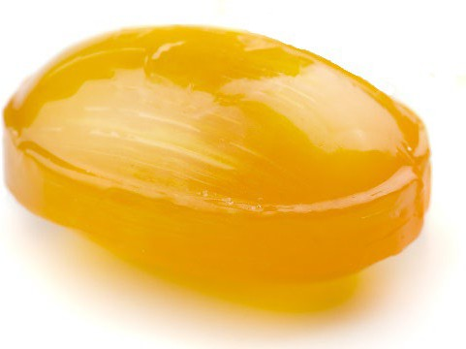**sore throat**

10 lozenges

Take when needed. Do not take more than 10 in one day.

cost: £10

**sore throat**



200ml of

paracetamol

medicine

Take 1 spoonful every 4 hours.

cost: £10

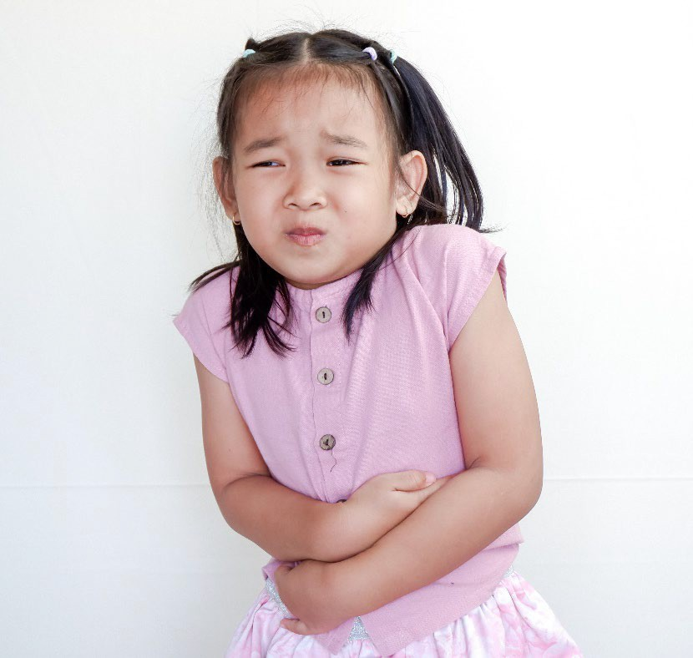

**stomach ache**

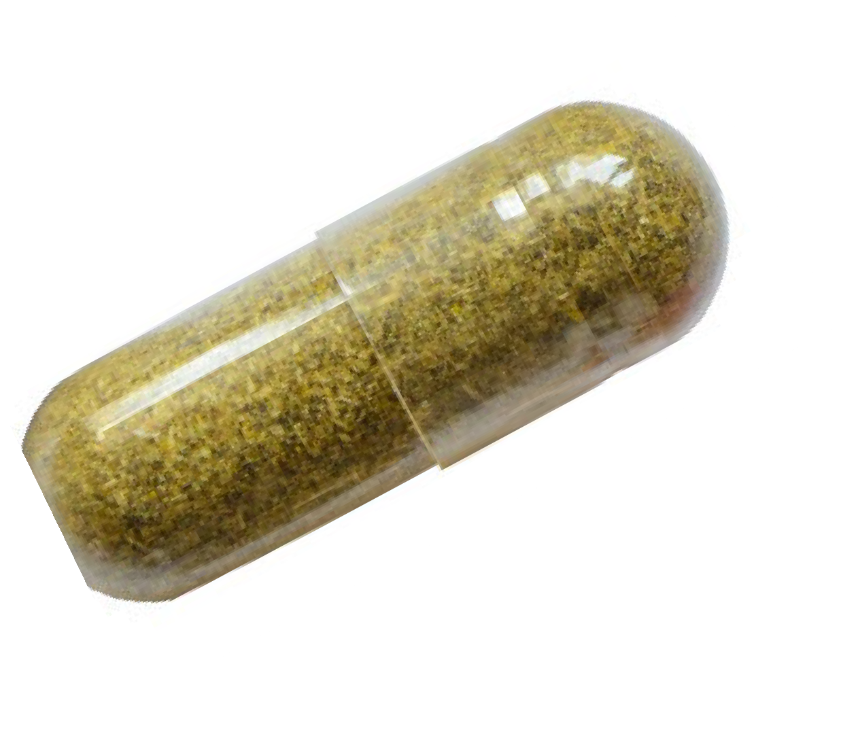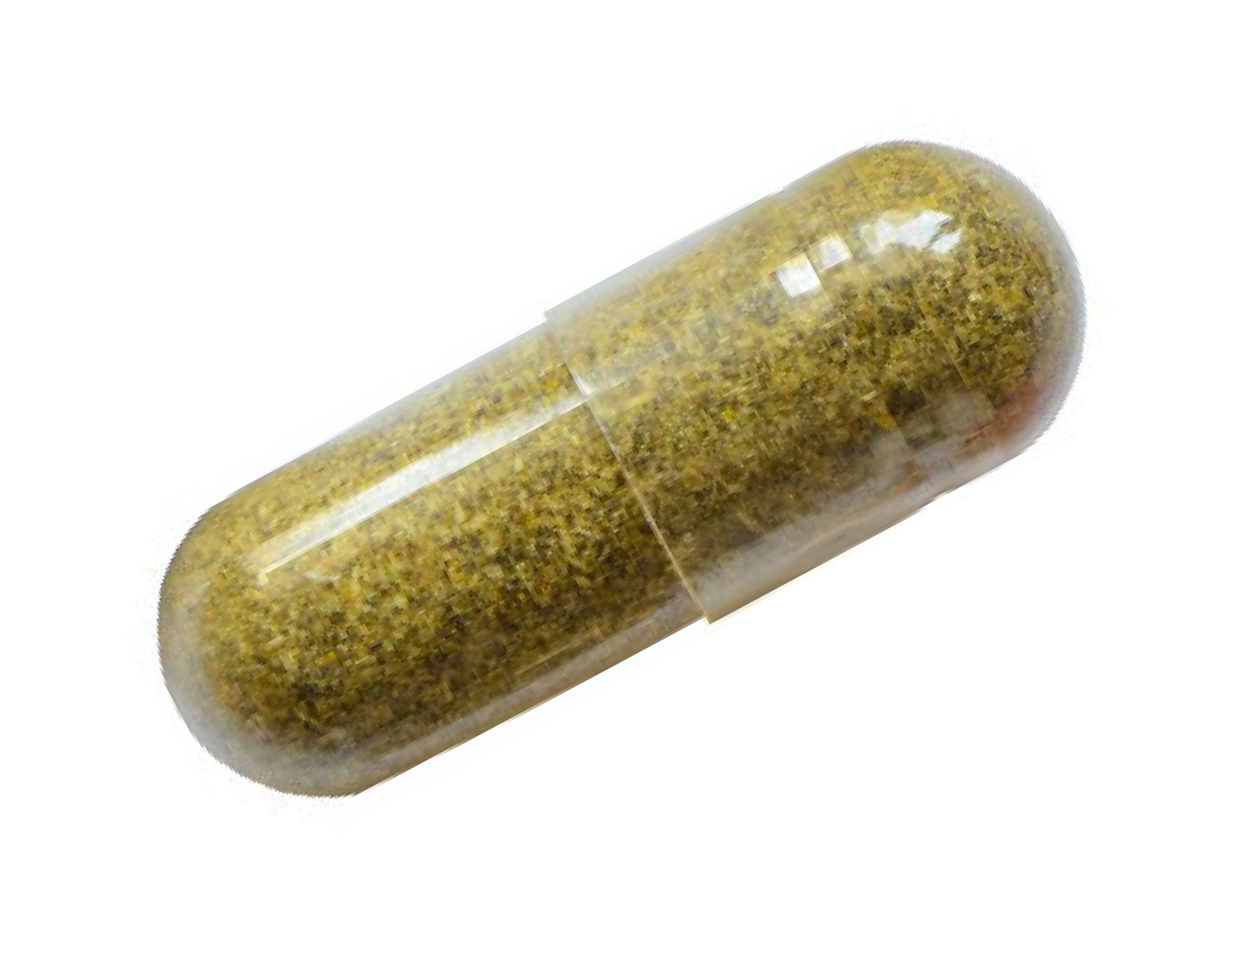

14 capsules

Take 2 capsules every day for 1 week.

cost: £10

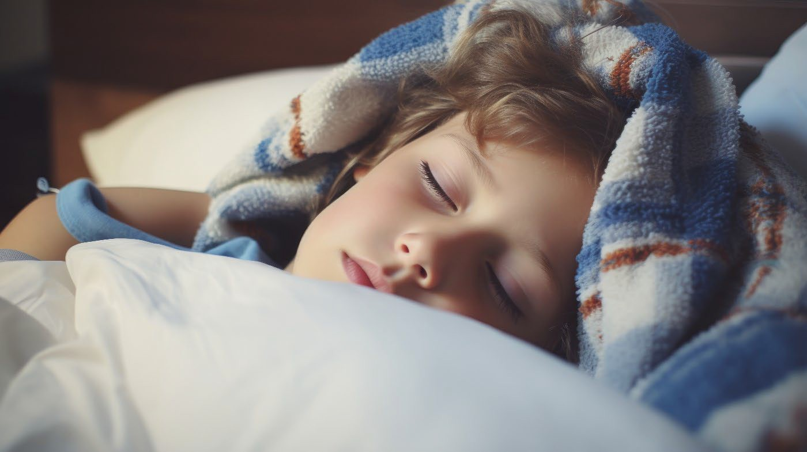

**feeling tired**

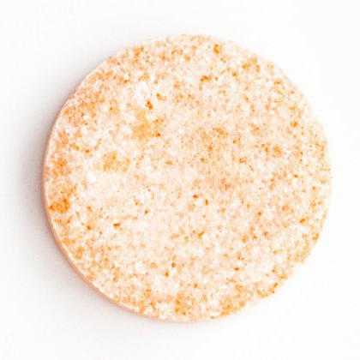

7 tablets

Take 1 per day for a week.

cost: £10