
allergies
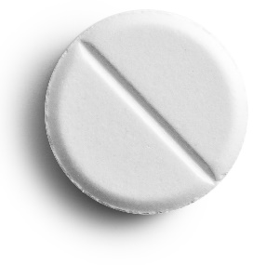
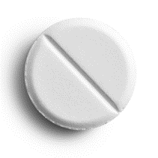
8 tablets

Take 2 tablets every 6 hours.
cost: £10


cough
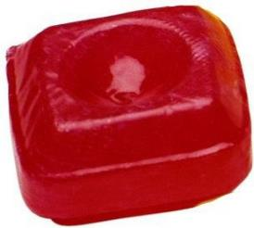
12 lozenges

Take when needed. Do not take more than 6 in one day.
cost: £10

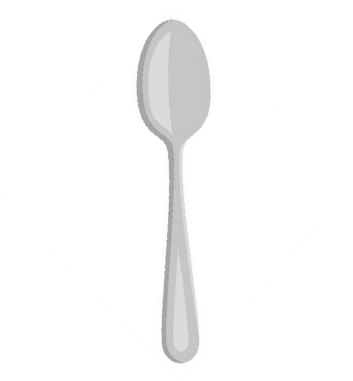
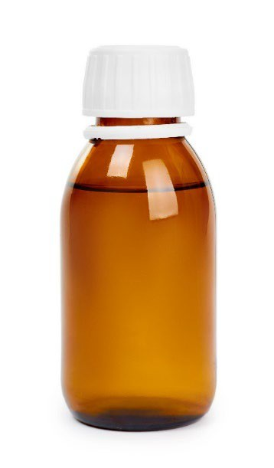
cough

300ml bottle of
cough mixture

Take 1 spoonful every 6 hours.
cost: £10


ear ache
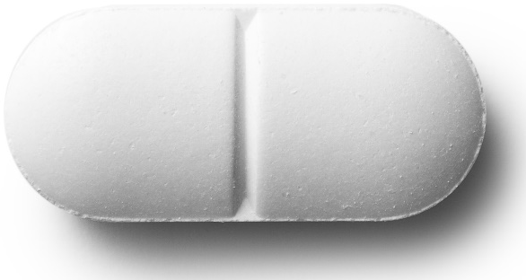
10 tablets

Take 1 tablet every 3 hours.
cost: £10


eye infection
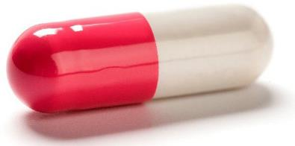
12 capsules

Take 1 capsule every 2 hours.
cost: £10


eye infection
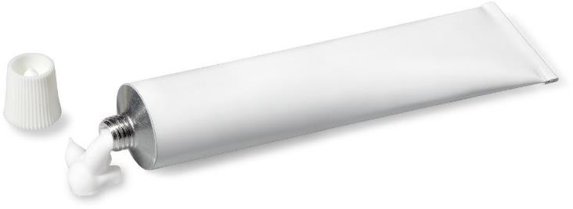

1 tube of ointment

Apply to eye every 3 hours.
cost: £10


head ache
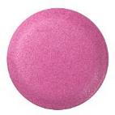
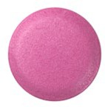
10 tablets

Take 2 tablets every 6 hours.
cost: £10


head lice
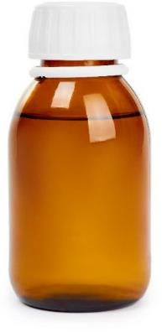
150 ml head
lice solution

Put all over hair.
Wash off after 1 hour.
cost: £10


rash
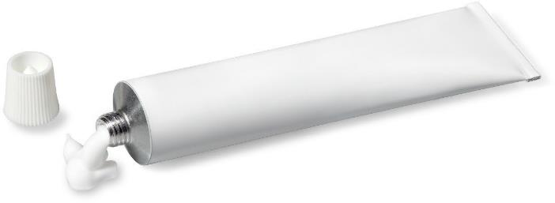
1 tube of cream

Apply to skin every 4 hours.
cost: £10

rash
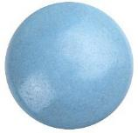
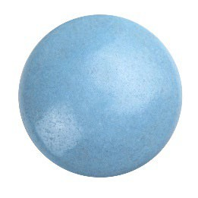
12 tablets

Take 2 tablets every 3 hours.
cost: £10


sore legs
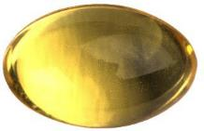
14 capsules

Take 2 per day for a week.
cost: £10


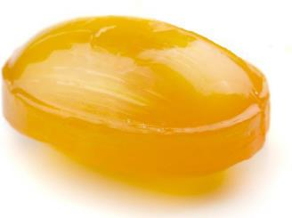
sore throat
10 lozenges

Take when needed. Do not take more than 10 in one day.
cost: £10


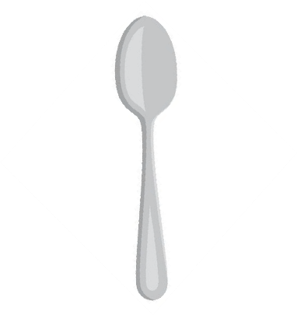
sore throat

200ml of
paracetamol
medicine

Take 1 spoonful every 4 hours.
cost: £10


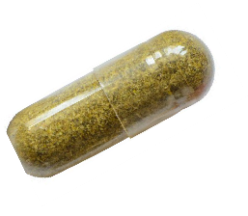
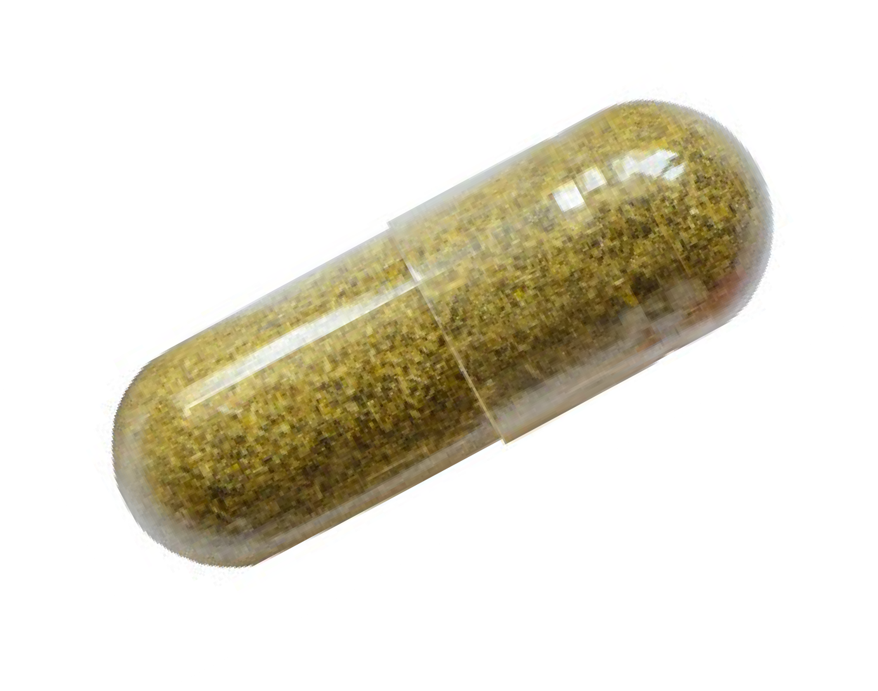
stomach ache

14 capsules

Take 2 capsules every day for 1 week.
cost: £10


feeling tired
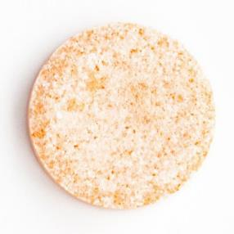
7 tablets

Take 1 per day for a week.
cost: £10

